## 

## 

## 

## 

## 

## 

Stoic Solutions

## 

## 

## 

## 

## 

## 

## 

Team (stoicsolutionscsusm@gmail.com):

Adam Hebel, Brian Rattanasith, Chris Bertram, Connor Myers,

Enrique Jimenez, Jerry Compton, Jordan Mower, Matthew Adamus

**Table of Contents**

**1. Application Development** 3

1.1 Statement of Business Context 3

1.2 Statement of Customer’s Business Problem 3

1.3 Statement of Project Proposal 3

1.4 Statement of Deliverables 3

1.5 Measures of Success 4

1.6 System Overview 4

**2. Requirements Matrix** 6

**3. Project Management** 7

3.1 Product Breakdown Structure 7

3.2 Work Breakdown Structure 8

3.3 Initial Schedule for Tasks and Deliverables 9

3.4 Statement of Total Price 13

3.5 Gantt Chart 13

3.6 Initial Project Cost Tracking Chart 15

3.7 Statement of Deliverables 16

3.8 Outline of Resources Needed 17

**Appendix** 18

To: Dr. Kristin Stewart, Assistant Professor of Marketing

CC: Dr. Shaun-inn Wu, Director of Projects

Stoic Solutions is thrilled to be a part of this amazing project for Keep America Beautiful. Thank you, Dr. Stewart, for providing us with this opportunity to be a part of not only a fun and engaging project but also a great cause. We looked forward to continuing our work with you this semester and making this project come to fruition.

The fourth phase involved the team modifying the fixIT script from the previous team to meet our needs, the creation of the database, and uploading/processing all of the gathered images of San Marcos through the machine learning algorithm into the database. In the next phase we plan to fine tune the database and make any adjustments necessary so that all the data in the database is up to par with what is needed by the UI team as well as finalize all documentation.

Regarding the accrued and projected cost of this project. Our team will be operating at a rate of $28.00 per hour. The estimated cost of Phase 4 was $4,319.30 but the actual cost was $4,597.70. Our estimated total cost, which includes our hourly rate and the cost of running the AWS server, amounts to $16,167.50 after the actual costs of Phase 1, 2, 3 and 4 have been calculated.

A copy of this report will be submitted to both Dr. Stewart and Dr. Wu

By signing below, you hereby approve Stoic Solutions to continue working on the following project: Keeping America Beautiful: Litter Detective and agree to the aforementioned estimated costs.

Thank you,

Chris Bertram (Project Lead)

stoicsolutionscsusm@gmail.com



___________________________________________ ______________

*Dr. Kristin Stewart, Assistant Professor of Marketing Date*

# **1. Application Development**

## 1.1 Statement of Business Context

Keep America Beautiful is a national non-profit organization that strives to improve, educate, and beautify both the environment and people. With more than 600-community based affiliates, partners, volunteers, and more, they are able to perform just so.

## 1.2 Statement of Customer’s Business Problem

* Keep America Beautiful needs the data produced by the algorithm to mean something.
* Needs the data produced to have a rating system.
* The definition of a geographical space must be defined to signify cities, counties etc.
* Make the data available and usable for the UI team.

## 1.3 Statement of Project Proposal

* Goal 1 - Collect data from 360 Google Street images.
* Goal 2 - Process images through ML.
* Goal 3.1 - Collect output data.
* Goal 3.2 - Define what a geographic space is.
* Goal 4 - Make data accessible to the UI team.

On behalf of Dr. Kristin Stewart we will implement the following with the intent of making this data usable and available to the UI team.

## 1.4 Statement of Deliverables

* Database filled with all data produced by the existing algorithm for UI team usage.
* Data will include:
  + Total litter in a given area.
  + Litter rating of 1 to 4.
  + Geographic space (Latitude, Longitude).
  + The date it was taken.

## 1.5 Measures of Success

**JAD 1 -** Identify requirements of the project.

**JAD 2 -** Finalize requirements of the project.

**Prototype 1 -** Bone works of database created. Image collecting script fine-tuned and

images collected and ready to be passed through the algorithm to collect

data.

**Prototype 2 -** More routes collected and a filled database of data from the San Marcos

area.

**Final Product** **-** Collation, transfer and storage of litter metrics from GSV360 images

that have been processed through a machine learning algorithm for use

by the UI team.

## 1.6 System Overview

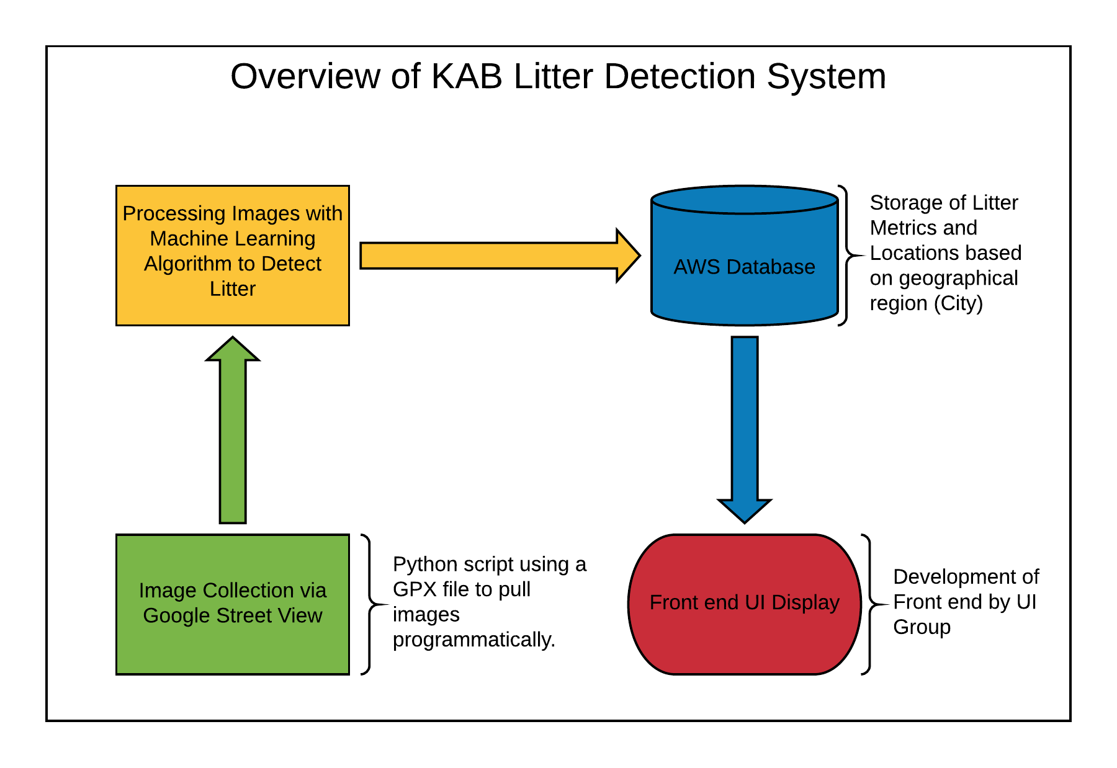

Table(s):

**Datapoint** ( datapoint_id, latitude, longitude, level_of_litter, num_litter_pieces, date_taken )

**ERD**

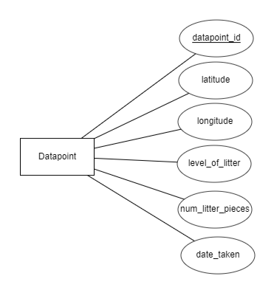

CREATE TABLE Datapoint (

datapoint_id INT AUTO_INCREMENT,

latitude FLOAT,

longitude FLOAT,

level_of_litter INT,

num_litter_pieces INT,

date_taken DATE

);

# **2. Requirements Matrix**

|  |  |  |  |  |  |
| --- | --- | --- | --- | --- | --- |
| Req. ID | Requirement | Description | Critical | Implemented [Y/N] | Task ID |
| 1 | Image Collection | - Script will capture 360 View, Google Maps, Google Street images and Plotaroute. | H | Y | 5.6, 5.6.1 |
| 2 | Machine Learning Processing | - Algorithm will process 360 google images.  - Will indicate trash in images. | H | Y | 5.6.2 |
| 3 | Organize Data from Algorithm into final product | - Algorithm will transfer data to database.  - Will organize into specified fields: total litter, litter rating, latitude, longitude, and date taken. | H | Y | 7.7, 7.7.3, 8.5, 8.5.1 |

# **3. Project Management**

## 3.1 Product Breakdown Structure

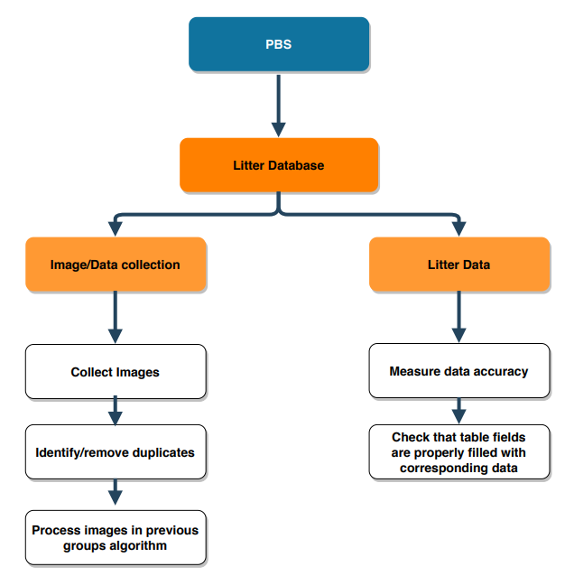

## 3.2 Work Breakdown Structure

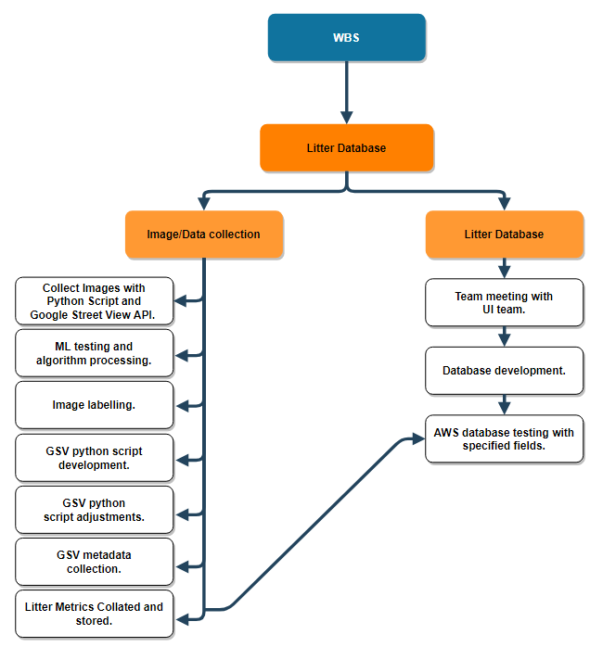

## 3.3 Initial Schedule for Tasks and Deliverables

**Schedule of Tasks:**

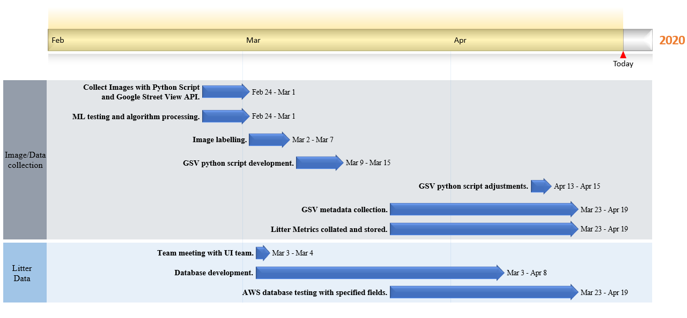

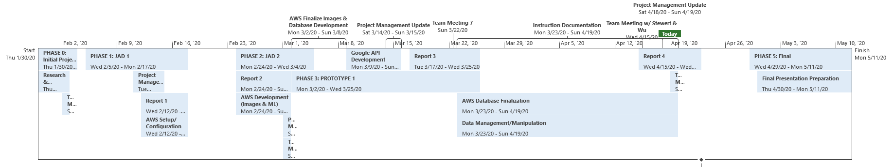

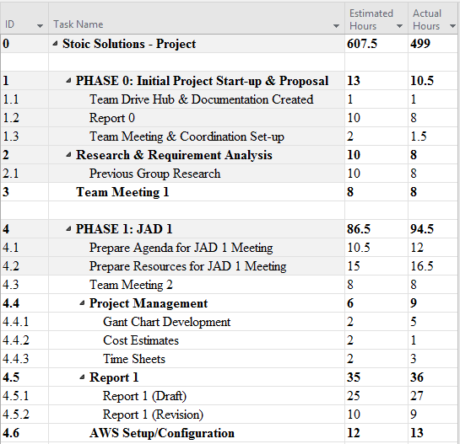

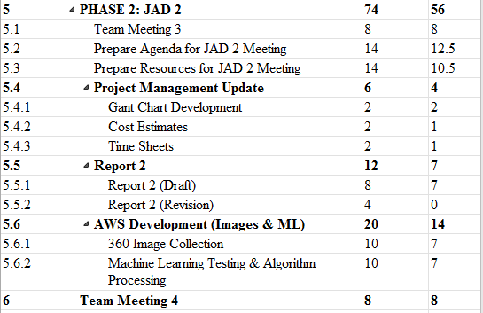

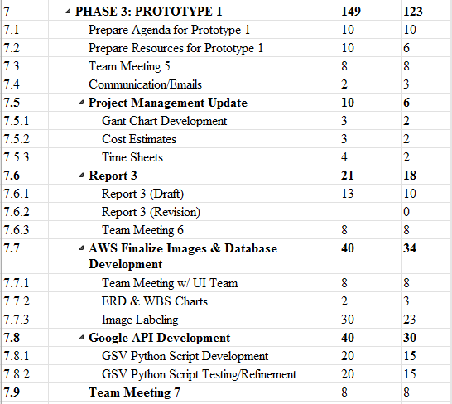

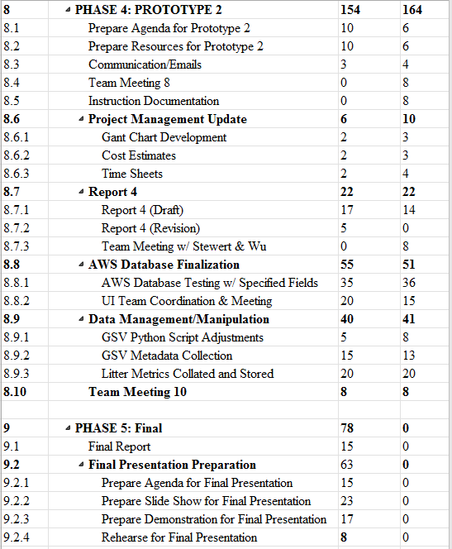

## 3.4 Statement of Total Price

As stated in our initial letter and agreement, the team will be operating at a rate of $28.00 per hour for each member of Stoic Solutions. The AWS server for the Machine Learning Algorithm will cost .29 cents per hour to run. The database server is a Free Tier AWS RDS t2.micro and comes with 750 hrs of free use. We can export the database so future groups can use the data if needed. Altogether, the estimated cost of the entire project with the actual costs of Phase 1, 2, 3 and 4 calculated is $16,167.50‬.

## 3.5 Gantt Chart

Our Gantt chart hours project actual hours for PHASE 0, 1, 2, 3 and 4. Projected hours for PHASE 5 is purely estimated in correlation to our current workflow and timeline.

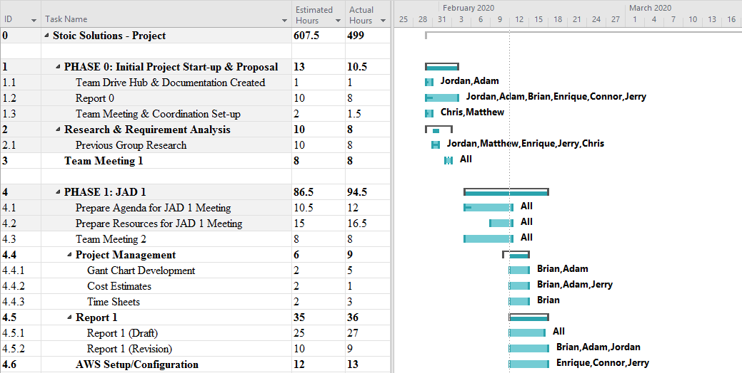

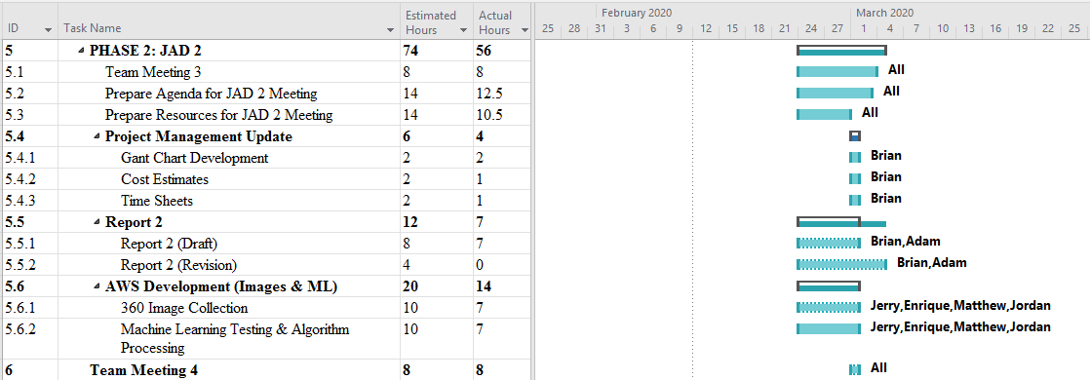

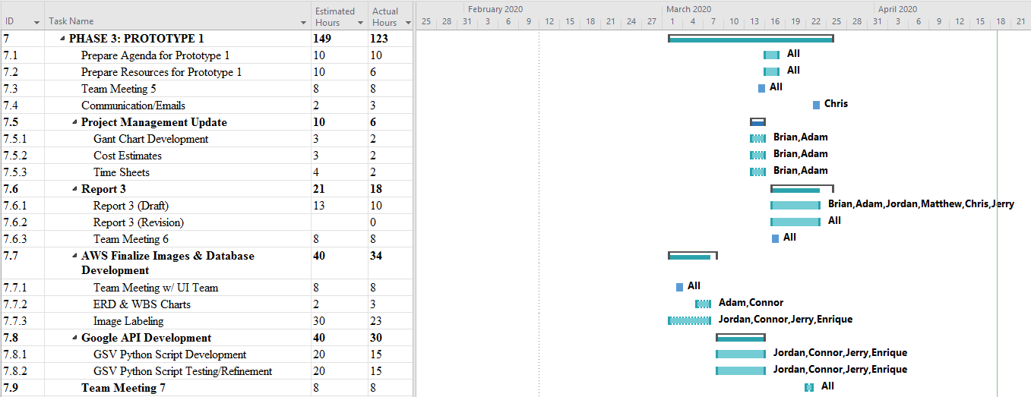

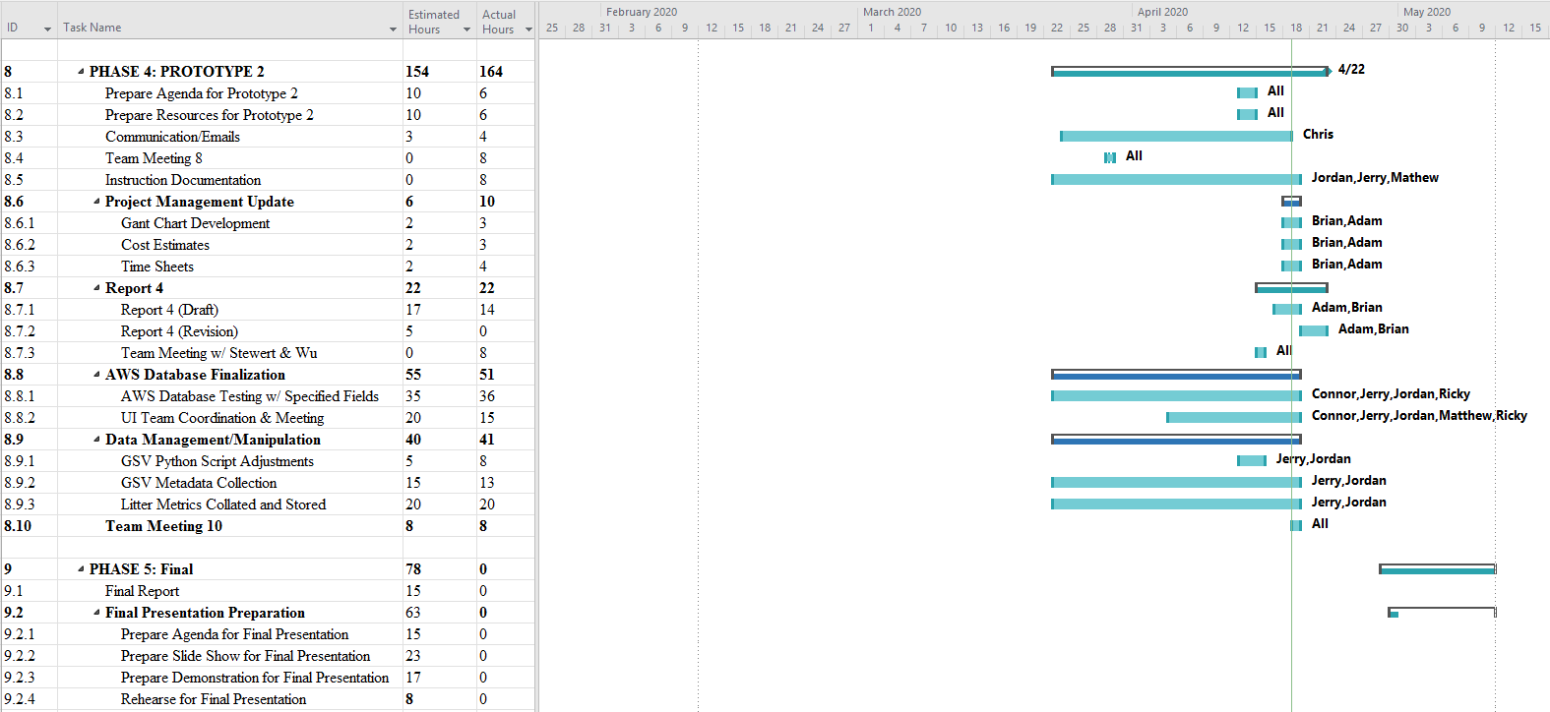

## 3.6 Initial Project Cost Tracking Chart

Below are the costs accumulated based on the team’s total hours worked. AWS was not configured entirely for Phase 0 & 1 but is represented and accrued at later phases. Phase 4 primarily consists of the most AWS uptime hours due to the fact that all of the images and database end work was completed in this phase.

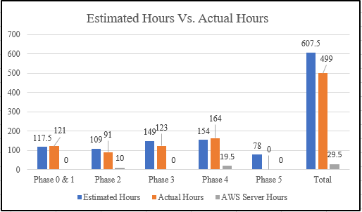

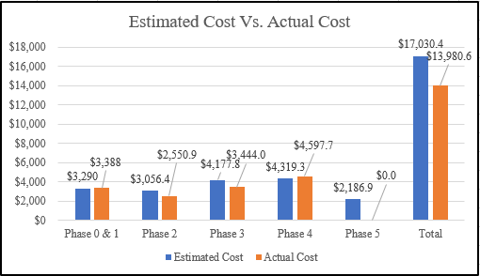

## 3.7 Statement of Deliverables

The Stoic Solutions team will deliver the following final products:

* Street2.1.py
  + Python script used for parsing GPX files, fetching images from Google Street View, and storing them locally on a machine.
* StoicSolutions_KABProcessor.ipynb
  + Python script used for processing images on the machine learning server and saving image data to a text file in the format: [Latitude], [Longitude], [KAB Rank], [Litter Count], [Date Processed].
* SanMarcosData.txt
  + Text file produced by StoicSolutions_KABProcesser.ipynb containing data for all processed images. This data is unrefined and is not representative of what will appear in the database. Mainly, there will exist duplicate latitude/longitude pairs because each coordinate produces two angles.
* Database Implementation & Details
  + Database ERD (Entity Relationship Diagram)
  + Database credentials and access parameters.
* Documentation
  + All above information is located on the GitHub link located below.
  + GitHub link: https://github.com/stoicSolutions/cis490_2020_project

The next phase is estimated to cost an additional $2,186.90 for the final portion of the project. The final phase will result in a database filled with data gathered from the images and documentation from Prototype 1 (Phase 3) and Prototype 2 (Phase 4) and will be used to finalize the project in Phase 5 (Due 5/11/20).

## 3.8 Outline of Resources Needed

The following resources are what the Stoic Solutions team will be supplying:

* Extensive Knowledge of AWS and database implementation.
* Updated documentation.
* Research and testing.
* Database credentials and access.

The following resources are what the Stoic Solutions team will need supplied from Dr. Stewart:

* Source code from previous team (Machine learning system).
* AWS Server Instance and Funding.
* Possible extra student labour to gather images since we will be doing a 360-view requiring 4 images rather than 1.
* Signage and approval for the Stoic Solutions team to continue working on the project.
* Availability for future meetings.

# **Appendix**

**Stoic Solutions Timesheets**

**Week 10:**

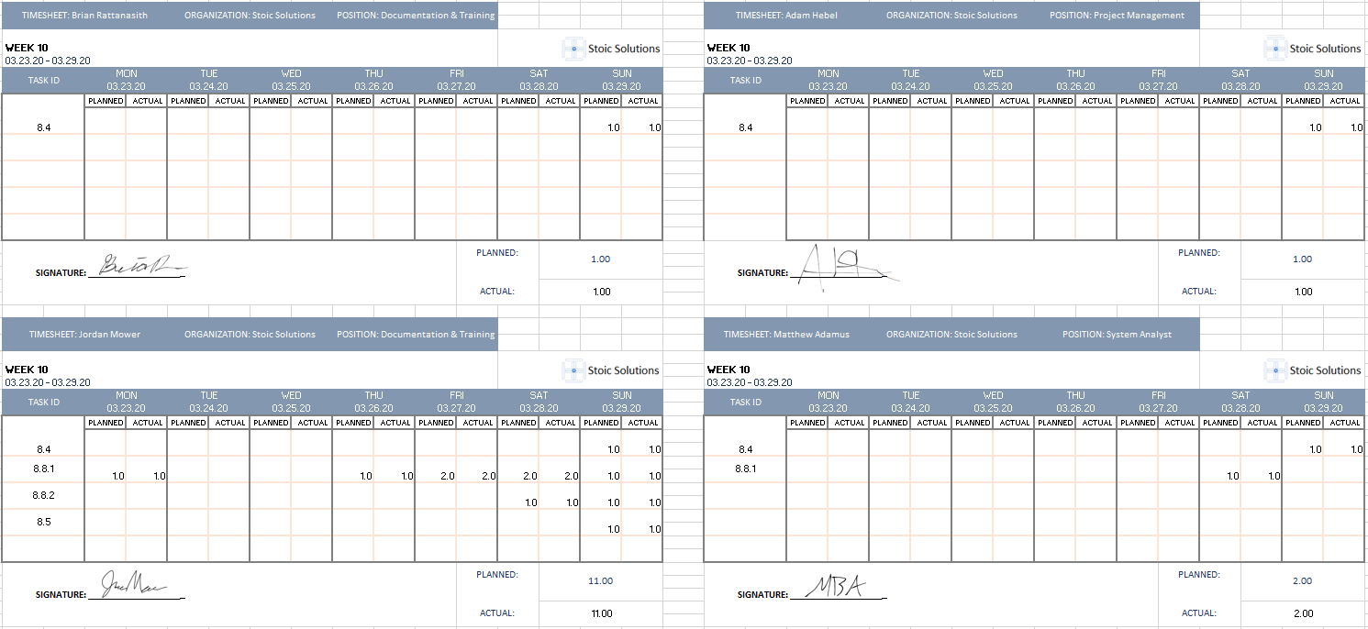

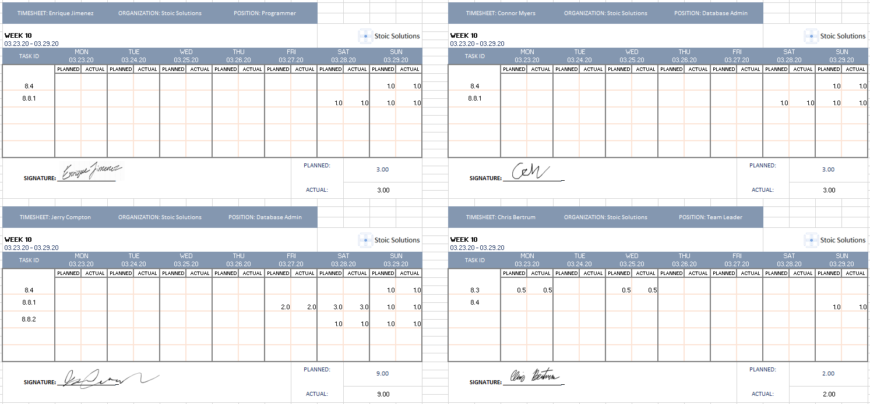

**Week 11:**

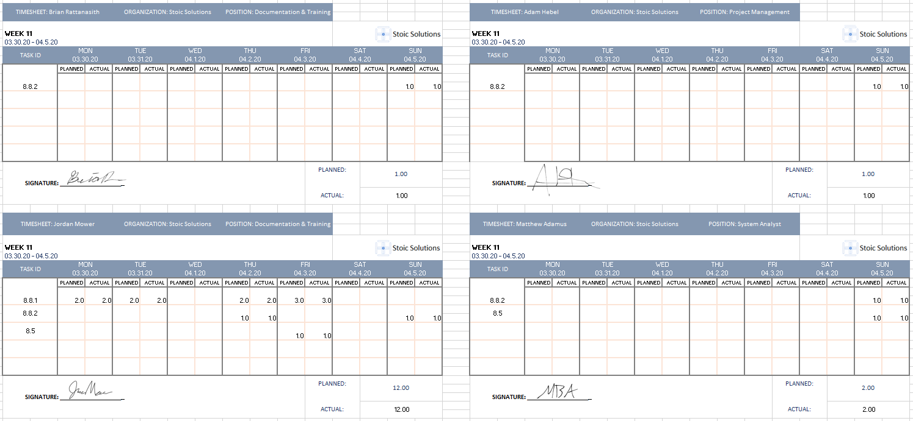

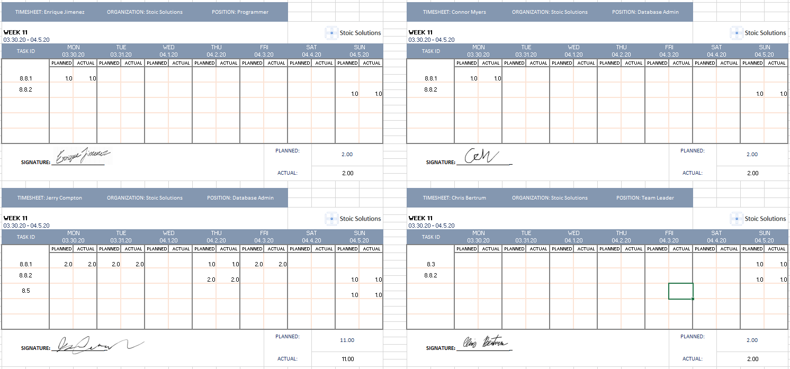

**Week 12:**

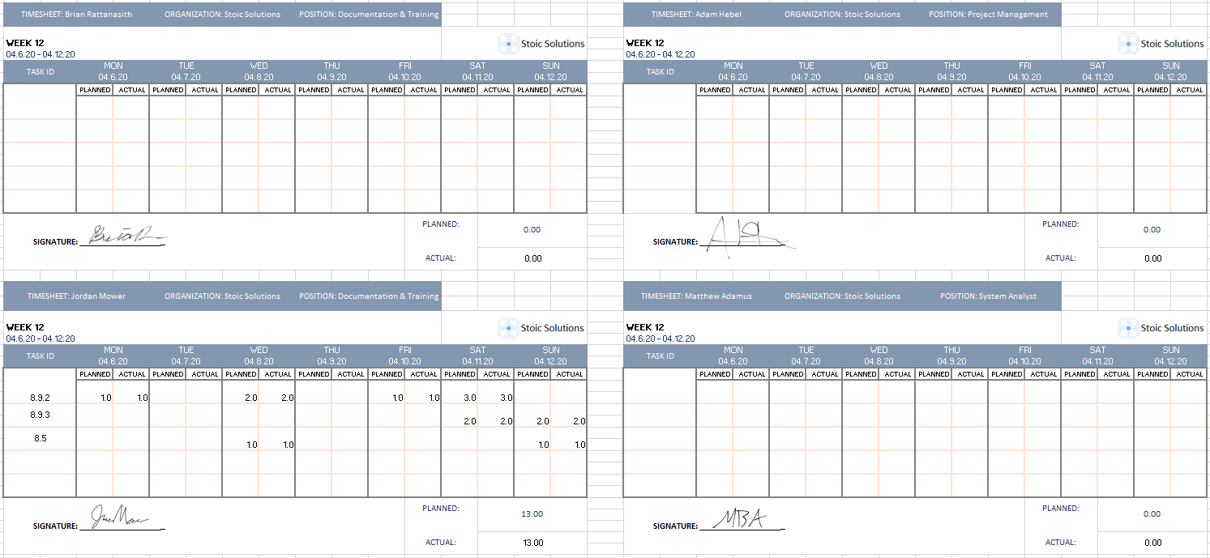

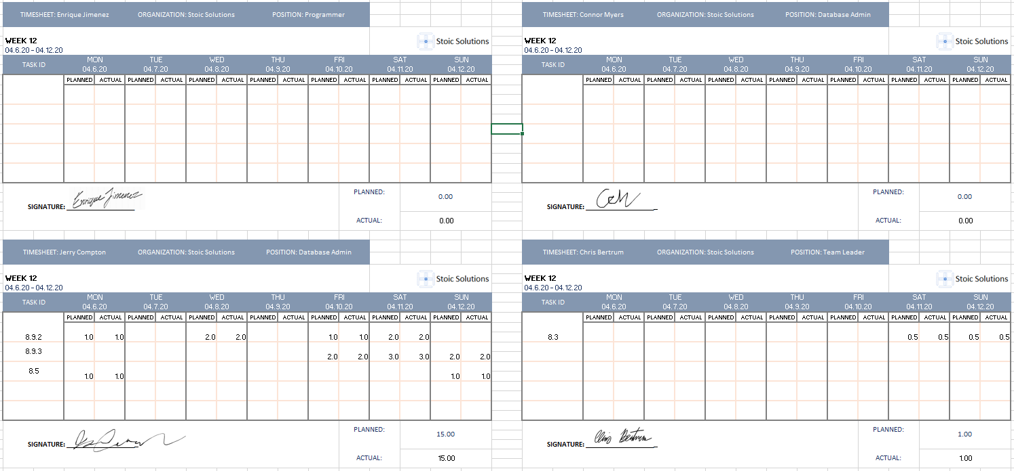

**Week 13:**

